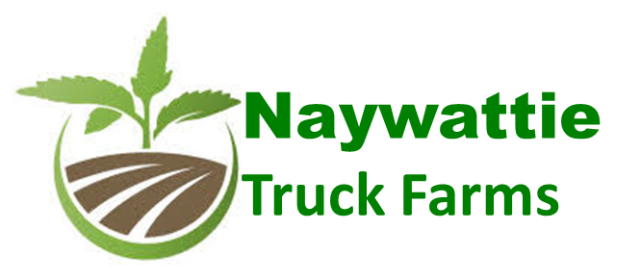

Le

Naywattie Truck Farms, Inc.

**Presented by:**

Stanley Davis

Founder & CEO

800-839-3290

c/o J. Roberts

Greenbriar-consulting.com

**Strategic Business Plan**

**June 26, 2019**

**CONFIDENTIAL DATA**

All Financials, Plans, and Business Projections contained herein are the proprietary property of Naywattie Truck Farms, Inc., and may not be copied, shared or disclosed to any third party without written permission.

ABSTRACT



**ABSTRACT**

**This Strategic Business Plan for Naywattie Truck Farms, Inc., hereinafter ‘NTF’ or ‘The Company’, has been prepared based upon a due diligent analysis of regional and national industry space for Hemp and Cannabis farming. In addition, The Company’s Business Model is based upon a Standard, 5-Year model.**

**Definition of Business Plan Approach:**

**This Business Plan is summary in nature because of the dependence on planned Equity Funding rather than public-intent venture capital. It is for this reason that the final business formation is an ‘S’ Corp.**

**Financial Model and Statements:**

**The Planning Horizon for the business plan is Five (5) Years and, as such, reflects Goals and Objectives on an Annual basis only. Detailed, Monthly Income Statements, Balance Sheets, and Cash Flow Analysis are available upon request.**

**Business Plan Compliance:**

**This Strategic Business Plan fits the format and content requirements for its business model and is suitable for external review by all Capital Investors, banks and an audit of intended business operations.**



TABLE OF CONTENTS

Cover Page .....................................1

Abstract..........................................2

Table of Contents...........................3

EXECUTIVE SUMMARY...................4

STRATEGIC PLAN………………………5

MISSION & VISION...………………….6

INDUSTRY FOCUS…….……...……….7

OPPORTUNITY….…….………………….8

PRODUCTS & SERVICES….…………9

COMPETITION….………………………13

OPERATING PLAN...………………….16

MARKETING PLAN...………………….21

FEASIBILITY STUDY…………………24

FINANCIAL SUMMARY....……………27

FINANCIAL STATEMENTS…....….….28



**EXECUTIVE SUMMARY**

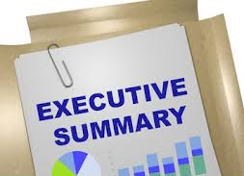

**INTRODUCTION:**

**Many Business Plans are produced in the U.S. annually. Rarely does a business opportunity emerge that has the potential to be a national force in the Hemp and Cannabis Farming Industry within simply a few years. That is precisely the potential of the business that you are about to learn about. It is the result of years of intensive research and exploration by the Founders and the resulting business model and its potential are significant by any standard. The emerging business we are speaking of is named Naywattie Truck Farms, Inc. It should be noted early on by Investors that this business has the potential to return 60+% bottom-line profit – an almost unheard-of accomplishment for a Hemp Grower.**

**BUSINESS CONCEPT:**

**Naywattie Truck Farms, Inc. is a grower of medical hemp and cannabis. Located in San Luis, Colorado – NTF will be growing hemp initially on 150 acres, which is a substantial undertaking. First the land must be cleared and the soil tested for chemical composition. Once it is known what the soil is composed of naturally it can be determined what additives, fertilizers and herbicides will be required to make the soil perform at the highest level of Hemp production.**

**We plan on leasing the land and equipment until it has been proven by a year of successful, profitable production. Then the acreage will be purchased, along with several larger tracts in Colorado. With a year of profitable production, we can move on to both Hemp growth expansion as well as our first crop of cannabis.**

**Initially, the business model calls for selling raw, harvested Hemp and Cannabis. Once we have an additional year of profitable harvests we will begin to produce derivatives and second-level products like CBD. We will also be erecting 8 50x100-foot green houses built within 4 years.**

STRATEGIC PLAN

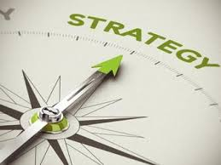

**PRIMARY GOALS:**

* **Obtain first round funding of $3 Million in support of the first group of farms.**
* **Emphasize both rapid development and geographical acreage expansion efforts.**
* **Hire a General Manager and Sales Executives.**
* **Achieve Profitability by the end of Year 1**
* **Experience Annual Revenue Growth at over 40+% throughout the first five years.**

## KEYS TO SUCCESS:

* **Rapid acquisition, and planting of profitable acreage.**
* **Quickly establish us as a major player in the Hemp & Cannabis Industry in Colorado.**
* **Bold moves into Derivatives and downstream products.**

[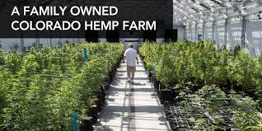](https://www.google.com/imgres?imgurl=http%3A%2F%2Flittlefieldscbd.com%2Fwp-content%2Fuploads%2F2018%2F08%2FHempFarm-Littlefields-1024x512.jpg&imgrefurl=http%3A%2F%2Flittlefieldscbd.com%2Fwhats-the-best-way-to-take-cbd-oil%2F&docid=RONQnWTJn-zuWM&tbnid=BS0_xN0zwY0nVM%3A&vet=10ahUKEwi7zJuBgYrjAhV4HDQIHaasBacQMwjCAShZMFk..i&w=1024&h=512&bih=522&biw=960&q=Hemp%20colorado&ved=0ahUKEwi7zJuBgYrjAhV4HDQIHaasBacQMwjCAShZMFk&iact=mrc&uact=8)

MISSION & VISION



**MISSION STATEMENT:**

**The mission of NTF is to produce corporate-grown Medical Hemp and Cannabis produced to exacting standards and quality. NTF is committed to the development of and resale of high-grade Hemp and Cannabis.**

**VISION FOR THE FIRST 5 YEARS:**

**Our Vision is to expand rapidly, acquiring and planting large tracts of farmland in Colorado, with Revenues of $75 Million in the first year – growing to $500 Million in Year 5.**

INDUSTRY FOCUS

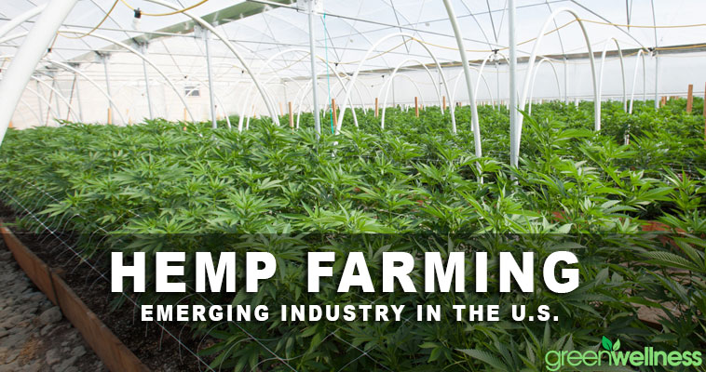

**U.S. Hemp and Cannabis Faming Industry**

**The U.S. hemp industry is expecting business to expand and investors to beckon after Congress passed the 2018 Hemp Farm Bill. This farm legislation includes a provision to legalize and regulate Hemp under the Department of Agriculture.**

**In the United States, hemp was a top cash crop for 150 years before it was banned over fears regarding marijuana use. Now, with legislation loosening restrictions on hemp cultivation, more farmers are turning to this hardy plant as a profit maker.**

**The retail market for hemp in the U.S. is approximately $600 million and expected to increase year over year. Globally, the market for CBD (the medically active ingredient in hemp) tops $33 billion per year. And with industrial hemp used in 30,000 products worldwide, demand is strong. But what does this mean for farmers who want a slice of the profits for hemp farming? Hemp Profit per Acre Can Be Substantial.**

**The 2018 Farm Bill will restore industrial hemp to nationwide legal production for the first time since World War II,** [**offering vast opportunities**](https://www.rochesterfirst.com/news/health/with-ok-from-congress-us-hemp-market-set-to-boom/1657930857) **for the industry and investment in a market expected to triple in four years.**

**With the removal of hemp from federal prohibition under the Controlled Substances Act of 1970 (CSA), the total U.S. hemp industry now looks to expand at a healthy 18.4% through a 5-year combined annual growth rate (CAGR) from 2018-2022. New Frontier Data’s** [***Hemp Business Journal***](https://www.hempbizjournal.com/) **estimates that, in leading all hemp product categories, the hemp-derived CBD market will grow from a $390 million-dollar market in 2018, to a $1.3 billion market (or 3.3x) by 2022, representing a 27.2% 5-year CAGR.**

[](https://www.google.com/imgres?imgurl=https%3A%2F%2Fhemp.rawmarket.place%2Fwp-content%2Fuploads%2F2019%2F04%2F20190424-RegisteredColoradoHempSeeds.jpg&imgrefurl=https%3A%2F%2Fhemp.rawmarket.place%2Fblog%2F2019%2F04%2F23%2Fregistered-colorado-hemp-seeds-premium-12-to-14-cbd-hemp-seeds-for-sale%2F&docid=7kwYlbaXOMx5gM&tbnid=QzRK2B9SaYt-NM%3A&vet=12ahUKEwjr7srNpIrjAhUCrZ4KHeM6CX84ZBAzKFUwVXoECAEQVw..i&w=300&h=250&bih=522&biw=960&q=Hemp%20colorado&ved=2ahUKEwjr7srNpIrjAhUCrZ4KHeM6CX84ZBAzKFUwVXoECAEQVw&iact=mrc&uact=8)

INDUSTRY FOCUS [Cont’d]

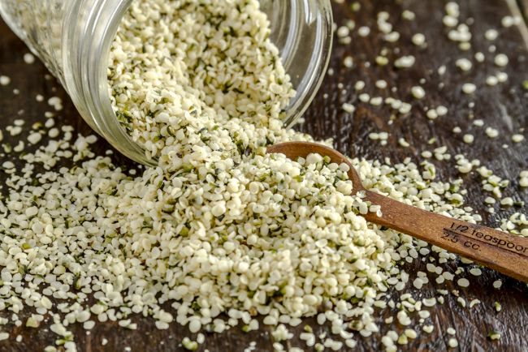

## HEMP FARMING ADVANTAGES:

**Hemp has many characteristics that make it an ideal cash crop. Here several reasons farmers get excited about the potential of industrial hemp.**

1. **1. It grows fast. The cycle from seed to harvest is only about 120 days. This means hemp can be planted before or after the growing season for other crops, allowing farmers to reap an additional cash crop from the same acreage.**
2. **2. It is hardy. Hemp can be grown virtually anywhere in the United States. At some point, agricultural experts will determine the “ideal” growing conditions for hemp. But in the meantime, farmers are finding that it thrives in a variety of soil conditions. It can even be used to help restore depleted soils.**
3. **3. It has few natural enemies. Biological pests that plague other crops tend to leave hemp alone, reducing the need to use pesticides. Hemp’s fast-growing nature also means it crowds out weeds. In the first six weeks of growth, hemp plants develop into a thick canopy of leaves that shade the ground, discouraging intrusion by unwanted plant species. This means herbicide and pesticide savings are substantial compared to other crops.**

## USES AND BENEFITS OF HEMP:

**Industrial hemp plants can become all kinds of useful products including rope, clothing, insulation, and even building materials. The seeds of the hemp plant are growing in popularity thanks to their nutritional properties. The health benefits of hemp seeds come from their high content of essential fatty acids, protein, and fiber.**

**Hemp and Cannabis – How they relate and how they differ: Hemp belongs to the same genus and species as marijuana – *Cannabis sativa*. With the legal status of marijuana being well known since the 1930’s, hemp has also found itself on the wrong side of the law, existing as a Schedule I narcotic since the 1970’s Controlled Substances Act.**

**However, hemp and marijuana are genetically very distinct plants. Crucially, hemp is legally defined as containing less than 0.3% THC by dry weight. THC (tetrahydrocannabinol) of course is the psychoactive compound that can be found in the cannabis plant, and it is responsible for causing the high associated with marijuana consumption. Since hemp contains very little THC, it can’t produce toxification.**

HEMP FARMING INDUSTRY

**Where is the Hemp Farming Industry Headed?**

**Rising acceptance for hemp and CBD – combined with easing regulations at the state level – caused U.S. hemp production to surge in 2017. From 2016 to 2017, the number of acres licensed for hemp cultivation in the top 10 hemp-growing states grew by 140% – while the number of hemp producers doubled over the same one-year period. It’s still very early for the U.S. hemp industry. Full-fledged hemp cultivation remains illegal at the federal level – the crop cannot be grown in a state that has not established a hemp program – and questions remain about the legality of hemp-based extracts like CBD.**

Hemp Production Trends:

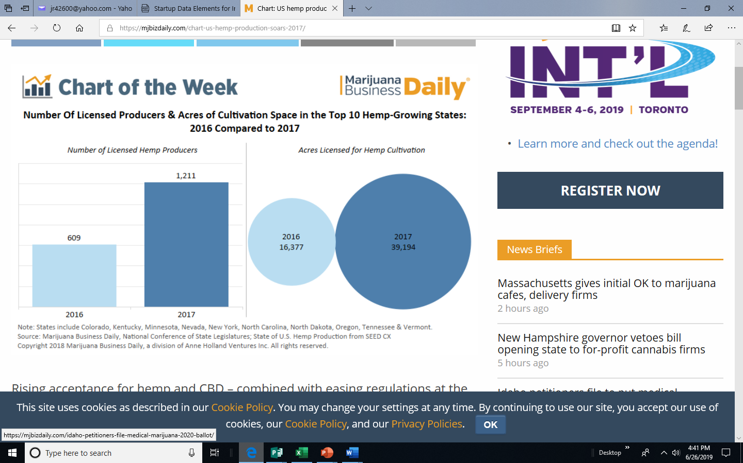

HEMP FARMING INDUSTRY

## HEMP FARMING AND STATE STATISTICS:

**The many uses for industrial hemp and its byproducts has prompted more traditional farmers to embrace hemp as a way to hedge against lower-value crops like cotton or alfalfa. And some states have shown a willingness to support the fledgling industry, allowing more growers into hemp programs and relaxing acreage limits across the board.**

**The number of hemp producers in Oregon, Tennessee, and Vermont more than tripled in 2017, while Minnesota, New York and North Dakota saw growth of 533%, 425% and 600%, respectively. Of the top 10 hemp-growing states, Kentucky and Colorado accounted for 81% of total acres registered for hemp production in 2016.**

**Though both significantly expanded their hemp programs in 2017, they now account for only 64% of total acres registered for hemp production. Excluding Colorado and Kentucky, the average number of acres licensed for hemp production was 374 in 2016; in 2017, average hemp production acres stood at 1,787 – a 377% increase.**

**Despite all the uncertainty surrounding the U.S. hemp market, entrepreneurs and policymakers are pushing ahead – clearly bullish about the industry’s future.**

**INDUISTRIAL HEMP & PROFITS:**

**Industrial hemp can be cultivated for seed, fiber, or pharmaceuticals (CBD oil). Seed and CBD command a much higher price than fiber. But all forms of hemp have good potential as cash crops for national use as well as export.**

**What are the numbers? To put things in perspective, commodities like wheat and soy may yield only $40-80 per acre. In contrast, farmers in Canada have been earning $250-300 per acre for hemp crops. U.S. farmers hope to do the same—or better. Some growers speculate that U.S. hemp could ultimately generate** [**$4,800 per acre in revenue**](https://www.agweb.com/article/colorado-farmer-shatters-hemps-fiber-ceiling-naa-chris-bennett/)**.**

HEMP FARMING INDUSTRY

[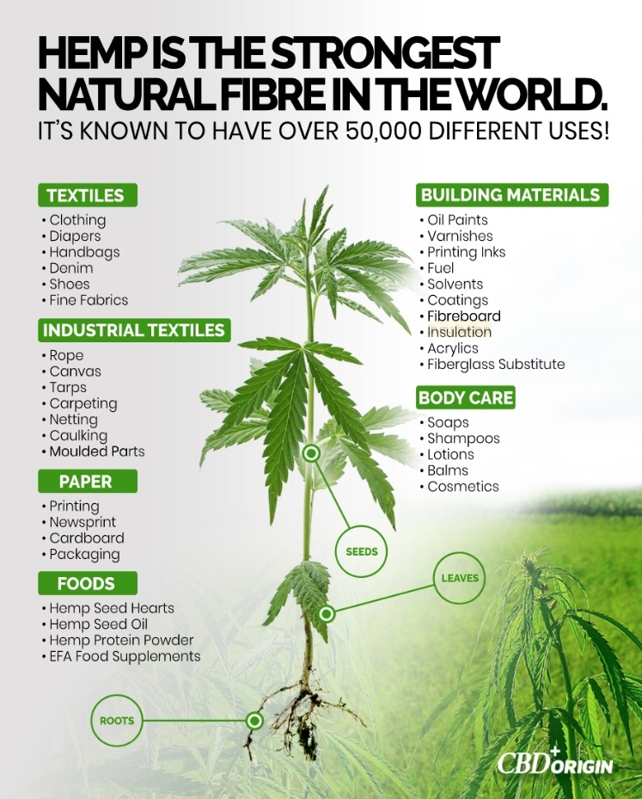](https://www.google.com/url?sa=i&rct=j&q=&esrc=s&source=images&cd=&ved=2ahUKEwi3msKdsYjjAhWaFjQIHR-ZAzkQjRx6BAgBEAU&url=https%3A%2F%2Fmedium.com%2Fcbd-origin%2Fhemp-vs-marijuana-the-difference-explained-a837c51aa8f7&psig=AOvVaw1C6JRg1N8xW-i7uNDSTYcV&ust=1561680994777953)

## The Environmental Benefits to Hemp Farming

**As Forbes notes, you can grow hemp in different types of climates, making it a viable farming option across the country. You can also grow it in differing soil types, something not possible in the marijuana industry.**

**Even more attractive is hemp is resistant to pests and weeds, eliminating two common challenges for farmers. With this alone, you can see why hemp farming has become such a popular alternative to the marijuana market.**

**You’re also able to pulp hemp plants using fewer chemicals thanks to low lignin content. A naturally bright pulp won’t require chlorine bleaching as a result.**

**While it’s easier to farm hemp organically than other crops, how do you go about choosing the right hemp plants?**

PRODUCTS AND SERVICES

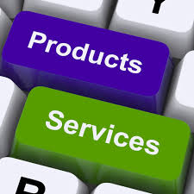

**Products:**

**Again, our Products are Hemp, Cannabis and, ultimately, the derivative products produced from refinement. Both Hemp and Cannabis has very high levels of derivative products which are both highly profitable and receiving extremely high consumer acceptance and demand with virtually no marketing or advertisements. Many CBD providers, for example sustain huge year over year growth in excess of 40% with NO marketing.**

**Because we will be growing our products – both Hemp and Cannabis – on company-owned farmland, we will be able to easily switch from product to product as the demand shifts over time. It is this pivotal capability which allows us to be so bullish.**

[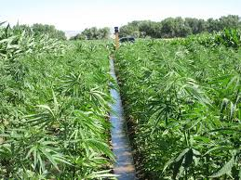](https://www.google.com/imgres?imgurl=https%3A%2F%2Fwww.colorado.gov%2Fpacific%2Fsites%2Fdefault%2Ffiles%2Fhemp_irrigation_Big.jpg&imgrefurl=https%3A%2F%2Fwww.colorado.gov%2Fpacific%2Fagplants%2Findustrial-hemp&docid=45ZfCEXMwsE6kM&tbnid=Row5Rq-D_ewspM%3A&vet=10ahUKEwi7zJuBgYrjAhV4HDQIHaasBacQMwhcKAAwAA..i&w=800&h=600&bih=522&biw=960&q=Hemp%20colorado&ved=0ahUKEwi7zJuBgYrjAhV4HDQIHaasBacQMwhcKAAwAA&iact=mrc&uact=8)

COMPETITION



**How NTF will differ:**

**NTF will clearly be in competition with every other Hemp Farmer in the U.S. However, we intend to lead the way, eclipsing our competition with the below strategy:**

**Locking up multiple plots of acreage in Colorado.**

* **NTF will actively seek out acreage that may/should be laying dormant yet highly farmable.**
* **We will work with the current owners and make them a cash offer to acquire the acreage.**
* **Once the tract is acquired, we will add it to the portfolio of owned acreage and perform the soil content analysis and get it cleared, plowed and planted.**
* **Once all available acreage in one County has been locked up, we will move on to the next County.**
* **This process will allow us to increase acreage under farmed control by up to a factor of 4 times per year.**
* **As a harvest year is approaching that harvest, we will determine whether to sell it outright or utilize it for downstream derivative product production.**

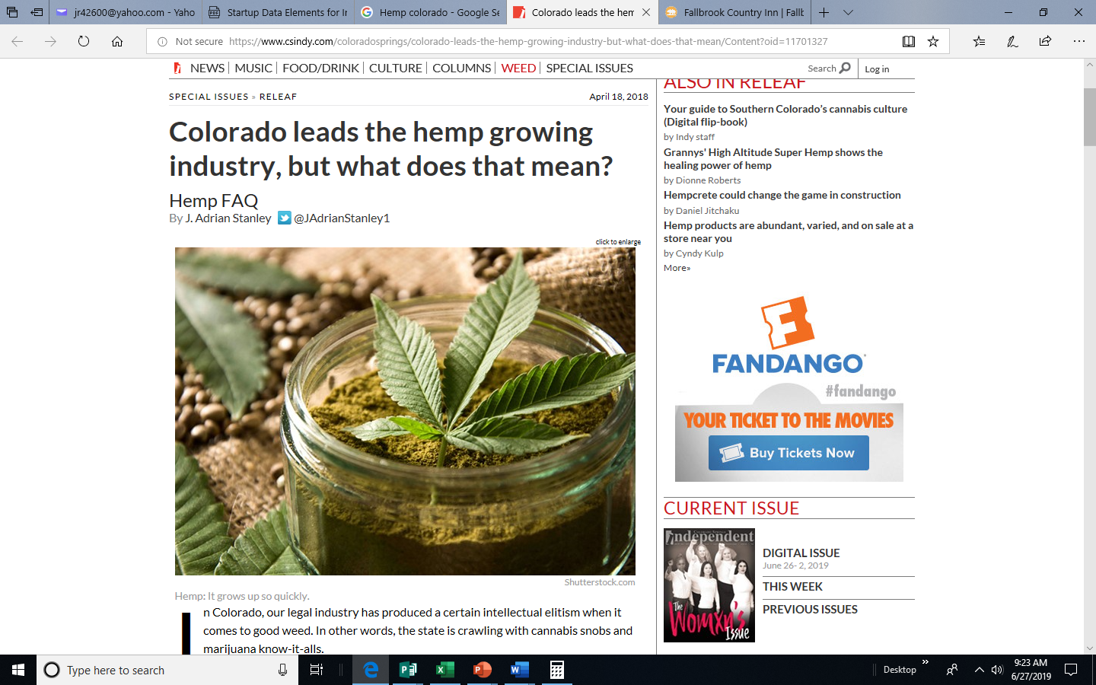

OPERATING PLAN

**OPERATING STRAGEGY:**

* **Develop an operating process which includes the rapid identification and acquisition of expanded acreage.**
* **Quickly get that acreage ready for planting, including soil analysis, surface preparation and planting.**
* **Fostering highly motivated team members and farm workers who excel in specific areas of expertise - including marketing, administration and support and equipment operation – i.e. planting, cultivation and harvesting.**
* **Create a financially expansive company that reinvests in its own success, invests in good acreage and in downstream product production – namely derivatives**

**and ultimately Cannabis and CBD.**



[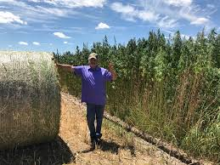](https://www.google.com/imgres?imgurl=https%3A%2F%2Fimages1.westword.com%2Fimager%2Fu%2Fblog%2F9768857%2Fhemp_2.jpg&imgrefurl=https%3A%2F%2Fwww.westword.com%2Fmarijuana%2Fcolorado-hemp-farming-has-a-stalking-problem-9768852&docid=CeFAW9KjKRCzCM&tbnid=vU6bFG2L21uRiM%3A&vet=10ahUKEwi7zJuBgYrjAhV4HDQIHaasBacQMwhfKAMwAw..i&w=613&h=460&bih=522&biw=960&q=Hemp%20colorado&ved=0ahUKEwi7zJuBgYrjAhV4HDQIHaasBacQMwhfKAMwAw&iact=mrc&uact=8)

OPERATING PLAN [Cont’d]

[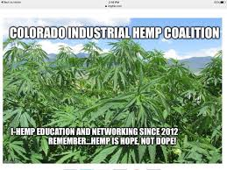](https://www.google.com/imgres?imgurl=https%3A%2F%2Flookaside.fbsbx.com%2Flookaside%2Fcrawler%2Fmedia%2F%3Fmedia_id%3D1103990326435611&imgrefurl=https%3A%2F%2Fwww.facebook.com%2FCoIndHemp%2F&docid=3vUKwAoHpyR4FM&tbnid=sosjTNJWuuT4dM%3A&vet=10ahUKEwi7zJuBgYrjAhV4HDQIHaasBacQMwifASg2MDY..i&w=960&h=720&bih=522&biw=960&q=Hemp%20colorado&ved=0ahUKEwi7zJuBgYrjAhV4HDQIHaasBacQMwifASg2MDY&iact=mrc&uact=8)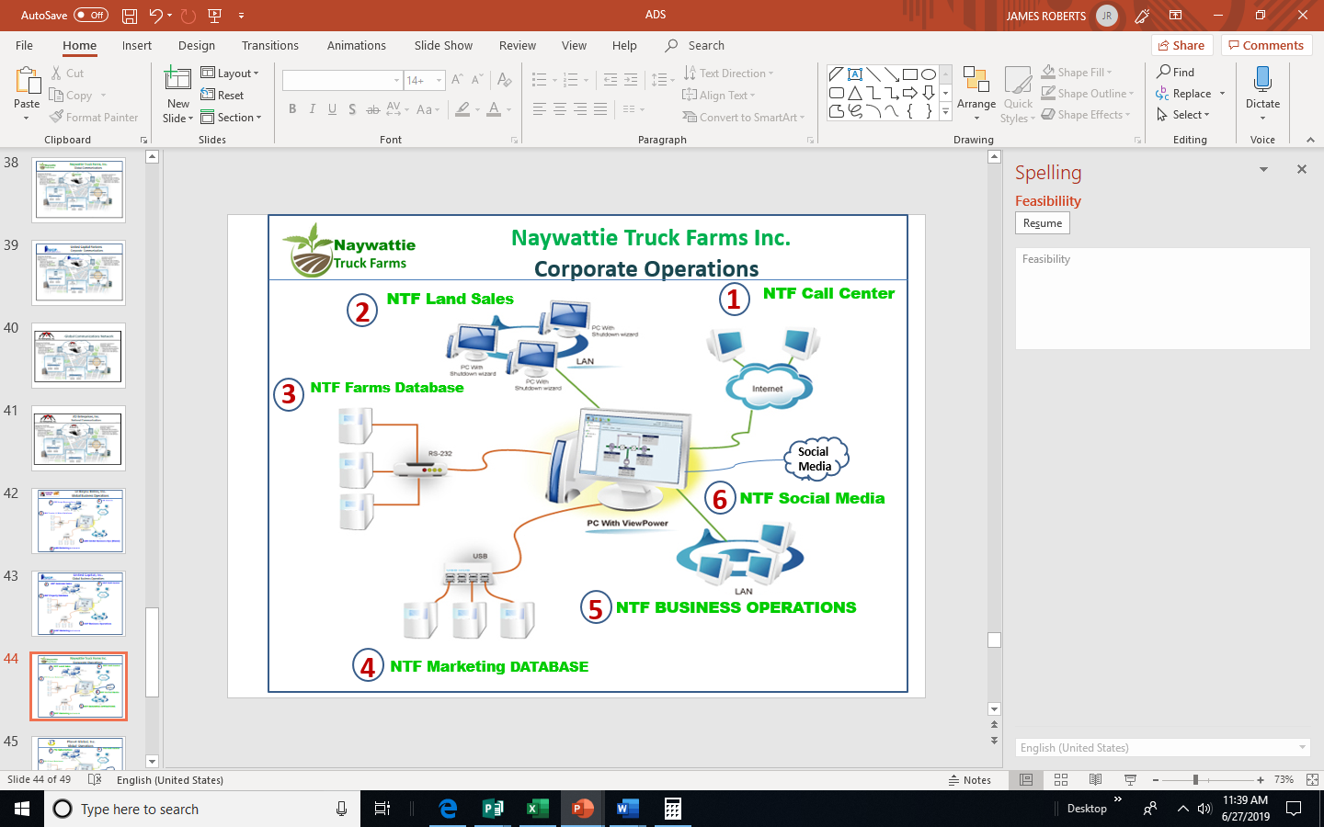

[](https://www.google.com/imgres?imgurl=https%3A%2F%2Fhemp.rawmarket.place%2Fwp-content%2Fuploads%2F2019%2F04%2F20190424-RegisteredColoradoHempSeeds.jpg&imgrefurl=https%3A%2F%2Fhemp.rawmarket.place%2Fblog%2F2019%2F04%2F23%2Fregistered-colorado-hemp-seeds-premium-12-to-14-cbd-hemp-seeds-for-sale%2F&docid=7kwYlbaXOMx5gM&tbnid=QzRK2B9SaYt-NM%3A&vet=12ahUKEwjr7srNpIrjAhUCrZ4KHeM6CX84ZBAzKFUwVXoECAEQVw..i&w=300&h=250&bih=522&biw=960&q=Hemp%20colorado&ved=2ahUKEwjr7srNpIrjAhUCrZ4KHeM6CX84ZBAzKFUwVXoECAEQVw&iact=mrc&uact=8)

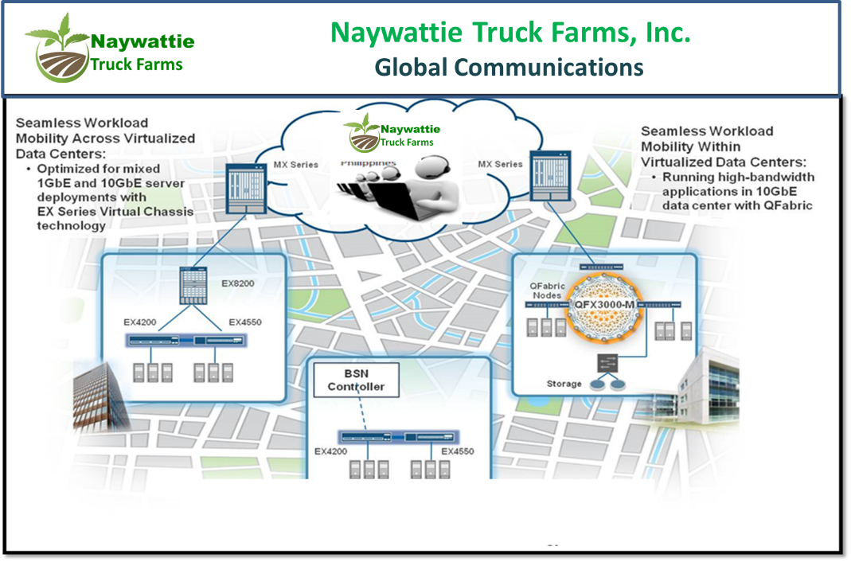

OPERATING PLAN [Cont’d]

**OPERATING FRAMEWORK:**

**In any organization, it is necessary for everyone to congruent as regards how the operating environment will function and flow. There need to be established Processes that will be followed as well as written, standard Policy & Procedures that are to be utilized in every situation requiring consistency and control. These need to be tied to the authorizing elements of the Strategic Plan so that resources are dedicated by priority, by time period, by department. The following graphic reflects the process that the Company will follow:**.

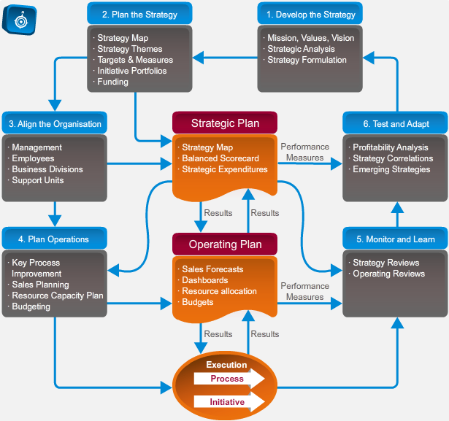

MARKETING PLAN



**MARKETING.STRATEGY: NTF looks to make our Marketing effort a full-court press, getting the word out to all interested and potential parties in the entire state of Colorado. In addition, we intend to rely heavily on technology-assisted marketing initiatives – like Webinars and Cable Advertising once we begin to sell CBD.**

**We also plan on quickly become the “place to go” when getting complete information regarding the Green revolution in growing Hemp. In doing so we will not only garner actual business revenues, but the byproduct of a massively growing contact base from which to launch specific Hemp Advertising and indirect marketing as well. We intend to quickly be a firm on the leading edge of Hemp Production in Colorado.**

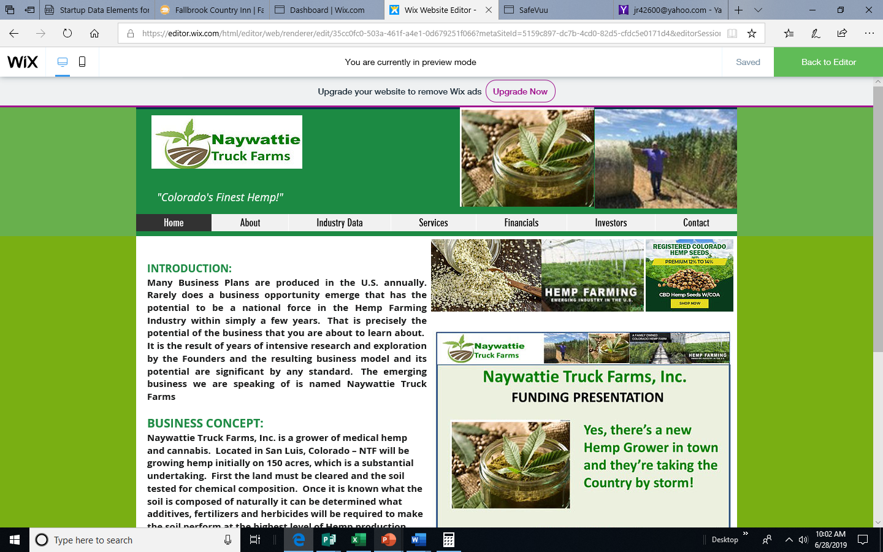**Below is a screenshot of the NTF Website:**

MARKETING PLAN [Cont’d]

**Below is a screenshot of the NTF Promo Video:**

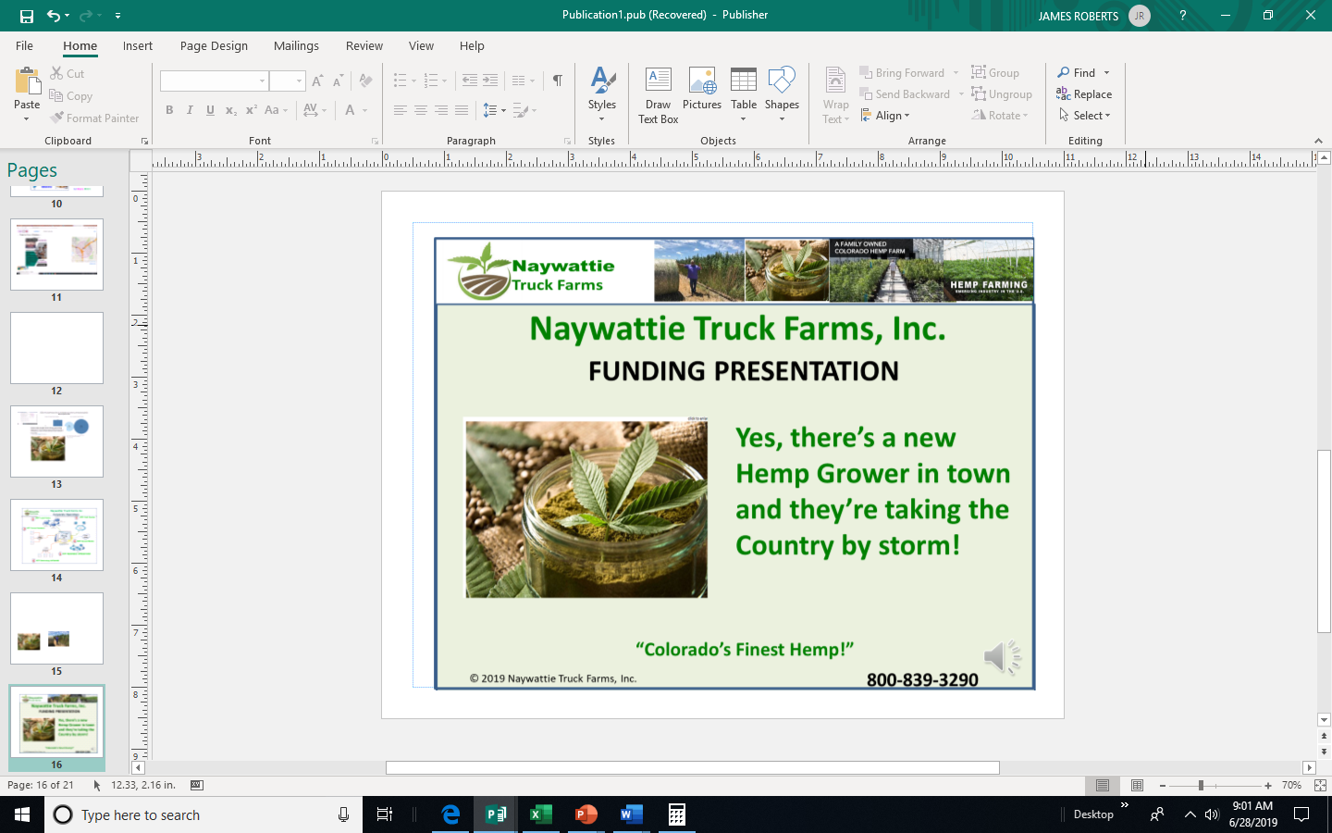

SALES INFORMATION:

**The entire world of Sales has seen a revolution in recent years, especially in regard to the manner in which Sales Activity, History and Closed Sales are recorded and managed. This process, now referred to as CRM – Customer Resource Management – can be expensive to manage but it need not be. There are many inexpensive CRM resources and database software that allow the prudent business owner to record and analyze both Sales-related Activity and closed business. The Company intends to utilize CRM inexpensively but effectively. We want to know what motivated a Franchiser to sign with us, and what and when a given Customer is likely to lease next.**

**Below is presented the type of Sales Information Dashboard that this software will provide.**

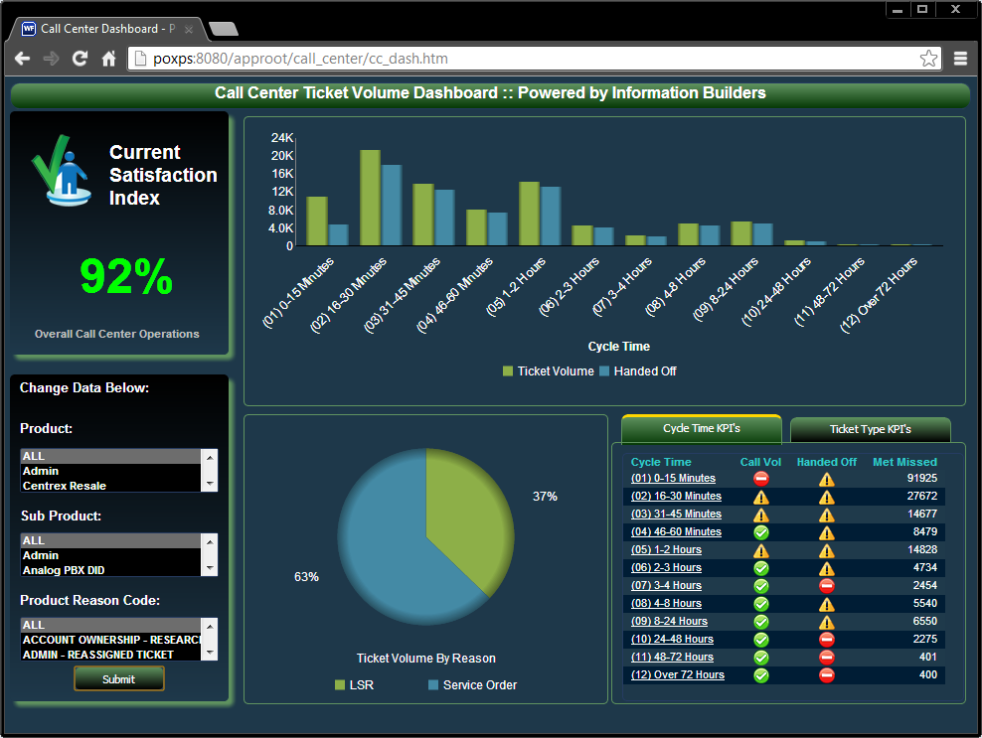

FEASIBILITY STUDY



**A Feasibility Study is appropriate when a Startup is offering a totally new product/service or is entering a market with apparently no or little competition and it is appropriate to analyze its probability of success in the marketplace, so that Investors may fairly and intelligently evaluate it. A Feasibility Study has two phases: 1) an SWOT Analysis – evaluating its Strengths, Weaknesses, Opportunities, and Threats; and 2) an assessment and presentation of its KPIs – Key Performance Indicators.**

**The SWOT Elements and Sub-Categories are presented in the below graphic. The KPIs are presented overleaf. Final KPI reflects an aggregate Startup assessment of ‘EXCELLENT’!**

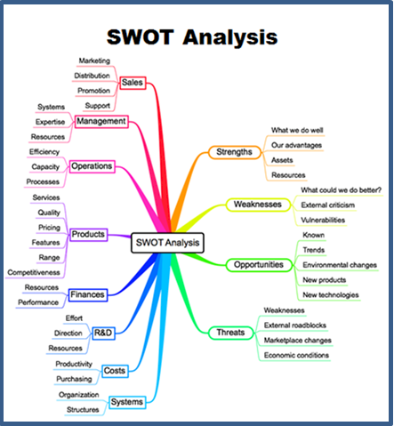

FEASIBILITY STUDY [Cont’d]

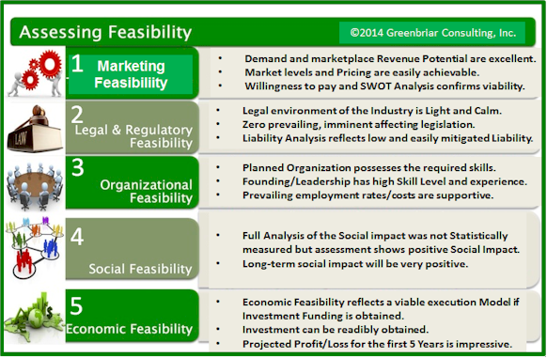

FEASIBILITY STUDY [Cont’d]

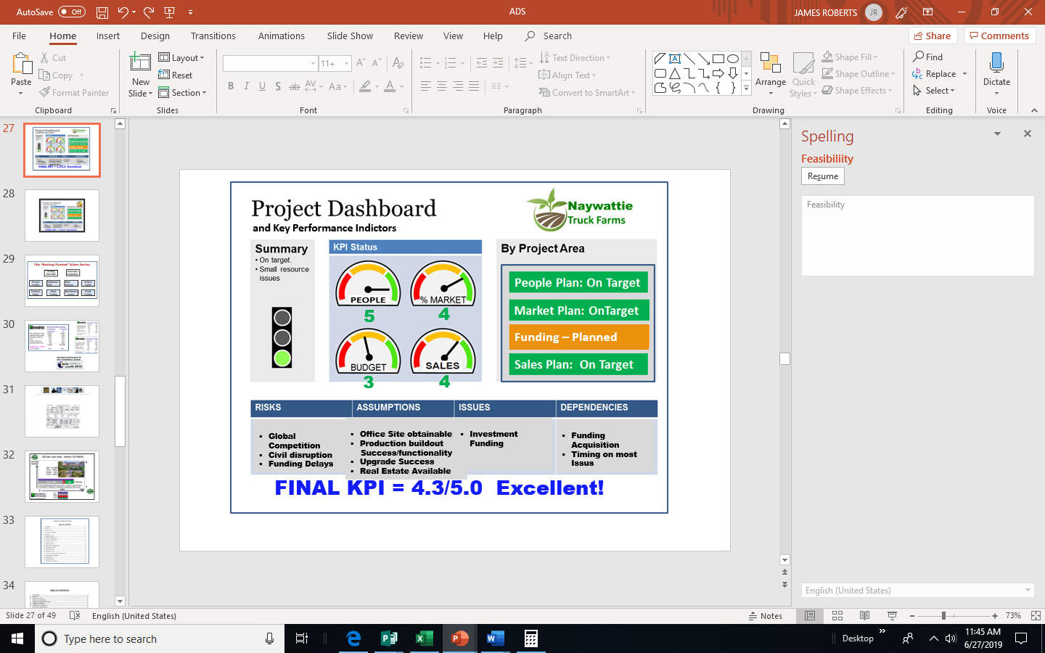

FINANCIAL SUMMARY



**FUNDING REQUIREMENT:**

**The company is currently raising an initial round of $3 Million Investor Funding for an ownership interest in the firm. The earnings-based valuation of the company [@12%] in Fiscal Year 5 will be approximately $566 Million.**

**While the Company is open to multiple Investment Scenarios, the preferred target Investor is an Angel Investor focused on the Hemp or Cannabis Farming Industry.**

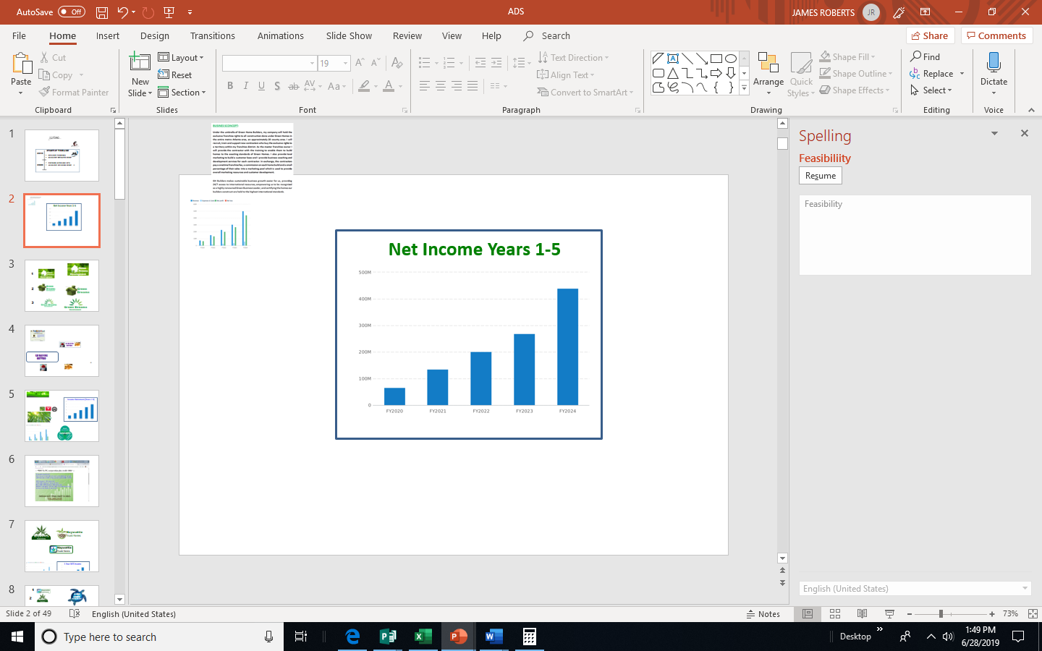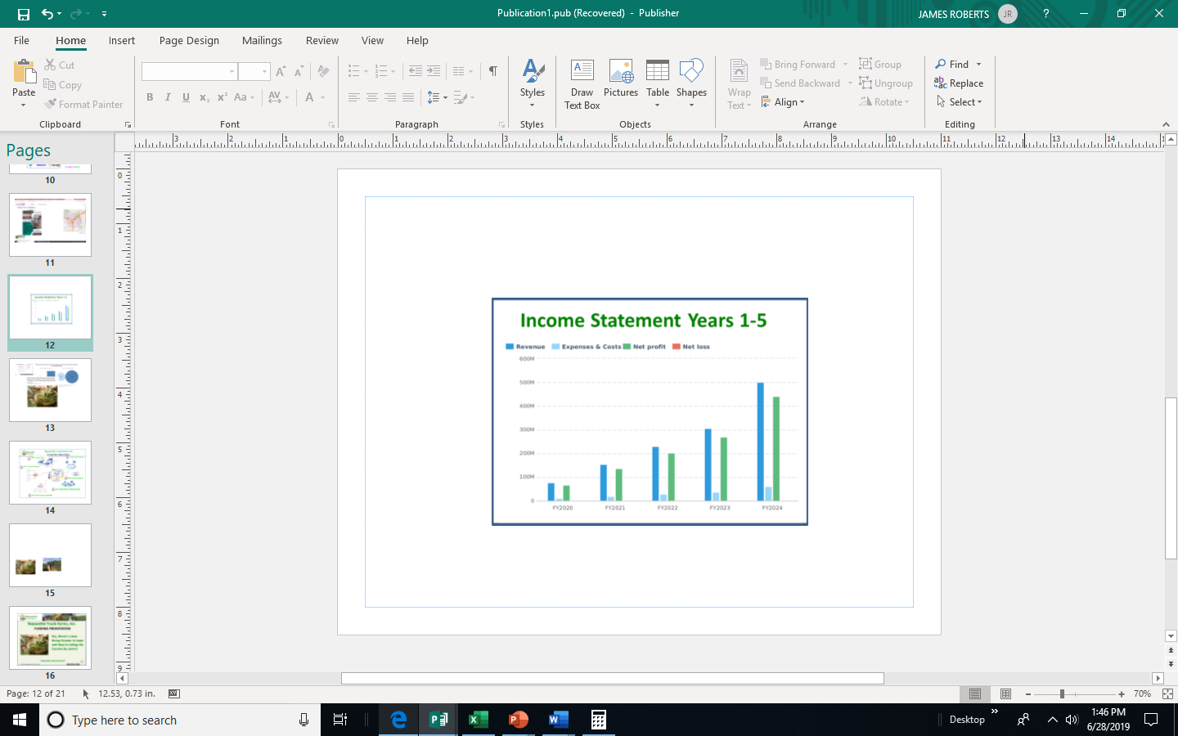

**FINANCIAL STATEMENTS:**

### Projected Profit and Loss

|  |  |  |  |  |  |
| --- | --- | --- | --- | --- | --- |
|  | FY2020 | FY2021 | FY2022 | FY2023 | FY2024 |
| Revenue | $75,000,000 | $153,000,000 | $229,000,000 | $305,000,000 | $500,000,000 |
|  |  |  |  |  |  |
| Direct Costs |  |  |  |  |  |
|  |  |  |  |  |  |
| Gross Margin | $75,000,000 | $153,000,000 | $229,000,000 | $305,000,000 | $500,000,000 |
| Gross Margin % | 100% | 100% | 100% | 100% | 100% |
| Operating Expenses |  |  |  |  |  |
| Farming expense | $9,000,000 | $18,360,000 | $27,480,000 | $36,600,000 | $60,000,000 |
| Total Operating Expenses | $9,000,000 | $18,360,000 | $27,480,000 | $36,600,000 | $60,000,000 |
|  |  |  |  |  |  |
| Operating Income | $66,000,000 | $134,640,000 | $201,520,000 | $268,400,000 | $440,000,000 |
|  |  |  |  |  |  |
| Interest Incurred |  |  |  |  |  |
| Depreciation and Amortization |  |  |  |  |  |
| Gain or Loss from Sale of Assets |  |  |  |  |  |
| Income Taxes | $0 | $0 | $0 | $0 | $0 |
| Total Expenses | $9,000,000 | $18,360,000 | $27,480,000 | $36,600,000 | $60,000,000 |
| Net Profit | $66,000,000 | $134,640,000 | $201,520,000 | $268,400,000 | $440,000,000 |
| Net Profit / Sales | 88% | 88% | 88% | 88% | 88% |

### Projected Balance Sheet

|  |  |  |  |  |  |
| --- | --- | --- | --- | --- | --- |
|  | FY2020 | FY2021 | FY2022 | FY2023 | FY2024 |
| Cash | $69,000,000 | $203,640,000 | $405,160,000 | $673,560,000 | $1,113,560,000 |
| Accounts Receivable | $0 | $0 | $0 | $0 | $0 |
| Inventory |  |  |  |  |  |
| Other Current Assets |  |  |  |  |  |
| Total Current Assets | $69,000,000 | $203,640,000 | $405,160,000 | $673,560,000 | $1,113,560,000 |
|  |  |  |  |  |  |
| Long-Term Assets |  |  |  |  |  |
| Accumulated Depreciation |  |  |  |  |  |
| Total Long-Term Assets |  |  |  |  |  |
|  |  |  |  |  |  |
| Total Assets | $69,000,000 | $203,640,000 | $405,160,000 | $673,560,000 | $1,113,560,000 |
|  |  |  |  |  |  |
| Accounts Payable | $0 | $0 | $0 | $0 | $0 |
| Income Taxes Payable | $0 | $0 | $0 | $0 | $0 |
| Sales Taxes Payable | $0 | $0 | $0 | $0 | $0 |
| Short-Term Debt |  |  |  |  |  |
| Prepaid Revenue |  |  |  |  |  |
| Total Current Liabilities | $0 | $0 | $0 | $0 | $0 |
| Long-Term Debt |  |  |  |  |  |
|  |  |  |  |  |  |
| Total Liabilities | $0 | $0 | $0 | $0 | $0 |
|  |  |  |  |  |  |
| Paid-In Capital | $3,000,000 | $3,000,000 | $3,000,000 | $3,000,000 | $3,000,000 |
| Retained Earnings |  | $66,000,000 | $200,640,000 | $402,160,000 | $670,560,000 |
| Earnings | $66,000,000 | $134,640,000 | $201,520,000 | $268,400,000 | $440,000,000 |

|  |  |  |  |  |  |
| --- | --- | --- | --- | --- | --- |
| Total Owner's Equity | $69,000,000 | $203,640,000 | $405,160,000 | $673,560,000 | $1,113,560,000 |
|  |  |  |  |  |  |
| Total Liabilities & Equity | $69,000,000 | $203,640,000 | $405,160,000 | $673,560,000 | $1,113,560,000 |

### Projected Cash Flow Statement

|  |  |  |  |  |  |
| --- | --- | --- | --- | --- | --- |
|  | FY2020 | FY2021 | FY2022 | FY2023 | FY2024 |
| Net Cash Flow from Operations |  |  |  |  |  |
| Net Profit | $66,000,000 | $134,640,000 | $201,520,000 | $268,400,000 | $440,000,000 |
| Depreciation & Amortization |  |  |  |  |  |
| Change in Accounts Receivable | $0 | $0 | $0 | $0 | $0 |
| Change in Inventory |  |  |  |  |  |
| Change in Accounts Payable | $0 | $0 | $0 | $0 | $0 |
| Change in Income Tax Payable | $0 | $0 | $0 | $0 | $0 |
| Change in Sales Tax Payable | $0 | $0 | $0 | $0 | $0 |
| Change in Prepaid Revenue |  |  |  |  |  |
| Net Cash Flow from Operations | $66,000,000 | $134,640,000 | $201,520,000 | $268,400,000 | $440,000,000 |
| Investing & Financing |  |  |  |  |  |
| Assets Purchased or Sold |  |  |  |  |  |
| Investments Received | $3,000,000 |  |  |  |  |
| Change in Long-Term Debt |  |  |  |  |  |
| Change in Short-Term Debt |  |  |  |  |  |
| Dividends & Distributions |  |  |  |  |  |

|  |  |  |  |  |  |
| --- | --- | --- | --- | --- | --- |
| Net Cash Flow from Investing & Financing | $3,000,000 |  |  |  |  |
| Cash at Beginning of Period | $0 | $69,000,000 | $203,640,000 | $405,160,000 | $673,560,000 |
| Net Change in Cash | $69,000,000 | $134,640,000 | $201,520,000 | $268,400,000 | $440,000,000 |
| Cash at End of Period | $69,000,000 | $203,640,000 | $405,160,000 | $673,560,000 | $1,113,560,000 |